### 2.Introduction (5% ~250 words)

o Describe your game, what is based on, what makes it novel?

Our game idea comes from classic platform shooter game in which you can fight with your friends. The aim of this game is simple, you need to keep jumping between different platforms which will be randomly generated and you must knock your opponent off of the arena using your weapons. This might seem easy, but it can prove quite difficult to knock your opponent off completely without getting hit yourself!

In the game we have several levels from easy to hard.In the easy mode, the platform will be falling very slow and your weapon will be weak and harmless,it is the mode suitable for novice and the people who first play this game. You can enjoy a relaxing and enjoyable leisure time with your friends.When you and your friends are familiar with the operation Instructions of this game, you can try medium mode. In medium mode the platform will not be that easy to jump to stand because it will be fallen faster. You need to be more focused on the game and be care of the bullets coming from your friends. In the hard mode, the platform will be fallen super faster and the speed of your bullet will be faster too. Which means you will be easily killed both by shooting and platforms falling. This game needs you to have good operation ability and psychological quality, try to use skills and tactics to beat your friends!

### 6. Evaluation (15% ~750 words)

### 6.1 Qualitative evaluation：

For evaluating our game design. We decided to use Think Aloud evaluation method to conduct qualitative testing of the game. And several test users are invited to explore and play our game freely with or without our guidance. And we asked them to thoughs aloud to express their experience.

We have found some problems during the test.e.g. The guidance at the beginning of the game is too vague, many players can't find the jump and shoot buttons correctly when playing the game for the first time; And the difficulty design have some problems, for example, the gap between the platforms sometimes too large so that players cannot jump up no matter the player try how hard.

To solve those problems , we improved our guidelines and adjusted our hardness settings. We need to strike a balance between playable and difficulty of the game.

One bug we found during the playing is that as the game’s setting, when a player fires a bullet at another player, the player who is hit is supposed to step back, but sometimes, especially when the player who is hit is moving towards the player who fired the bullet. The hit player will move in the direction of the firing bullet. To solve this problem, we adjusted many parameters like the bullets speed, bullets length, and the player’s length. Finally we found that the problems comes because of lowness of the screen refresh rate. Some times when the screen detected the collision between players with the bullets, the bullets have already moved across the player. So we adjusted the function of the collision and shorted the body of the bullets.

### 6.2 Quantitative evaluation：

In order to gain more data to improve our game. We added some instructions and solved some bugs and problems happened before. Then we invited more people to experience the game and asked them to fill the NASA TLX and System Usability Scale forms after their experience.

We have six dimension to evaluate players cognitive and psychological load during the game playing in different difficulties.

The content of NSA TLX have six dimension. In the first mental demand , we asked:

1. How quickly does the game's platforming disappear?
2. How much attention does the player need to dodge enemy attacks?
3. How much decision making is required during the game?

In the second physical demand , we asked:

1. How much hand-eye coordination does the player need to shoot the enemy?
2. How much time is needed to move and dodge attacks?
3. How much power does the player need to use to control the game?

In the third temporal demand , we asked:

1. How long does it take players to complete tasks in the game?
2. Does the game move too fast or too slow?
3. Does the player have enough time to think and make decisions?

In the fourth performance demand , we asked:

1. Are players satisfied with their performance in the game?
2. What is the player's assessment of his or her skill level?
3. How is the player's emotional experience in the game?

In the fifth part effort , we asked:

1. How much effort does the player need to make to control the character in the game?
2. How much effort does the player need to stay alert and focused?
3. How much effort does the player need to remember the mission objectives and how the enemies attack?

In the sixth part frustration , we asked:

1. How difficult are the tasks required in the game?
2. How many different tasks are there to complete?
3. Does the difficulty of the tasks match the skill level of the player?

We asked same questions for different people who was playing different difficulty levels. It can be easily found that the pressure get higher along with the harder mode. We found that in the hard mode people generally feeling unsatisfied about their performance, which means the game was too hard to play and the player cannot be satisfied during the game.

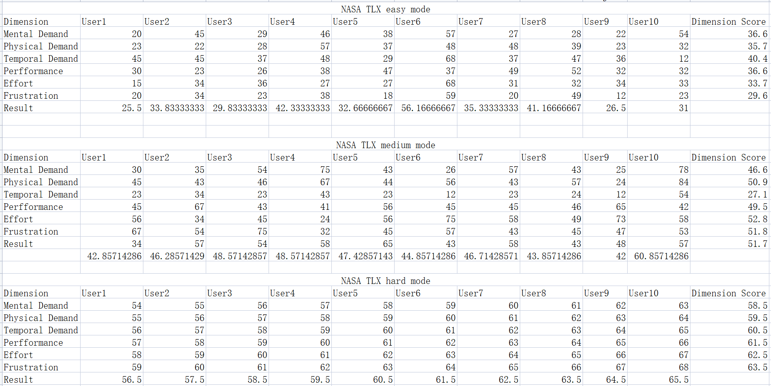

We have ten questions of SUS writing below:

1. I found the game very easy to pick up.
2. I had a smooth action in the game.
3. I felt that the weapons and props in the game worked well.
4. I found the objectives and missions in the game to be clear.
5. I found the enemies and mechanics in the game challenging.
6. I thought the graphics and sound effects were cool.
7. I found the scenery and backgrounds in the game attractive.
8. I found the story and storyline in the game interesting.
9. I found the difficulty settings in the game to be appropriate.
10. I found the gameplay in the game interesting.

Through the SUS graph we can see that players did not give us a very good satisfactory scores. There are some aspects we still needs to improve to make the user to feel easy to use and understand. And some game backgrounds needs to be added to make our story looks easy to understand.

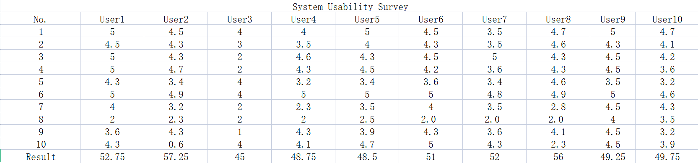

**6.3 How code was tested：**

As we are using processing as our platform. We did not provide any testing code to run our game.We mainly focused on user testing like Think Aloud evaluation, NASA TLX and System Usability Survey (SUS) methods.

The Think Aloud evaluation methods mainly focused on debug and to find out some unreasonable part during the gameplay. And it worked well in checking our outline guidance whether clear or not too. It really helped us make a game that has good interaction and is quick and easy to play.

Based on the result of the questionnaire, we can conclude that our game have a very nice special effects which attracts the players most. Combined with the good audio effects, the overall experience is very good. After the Think Aloud evaluation methods we redesigned our interface which have become simple and clear. Some drawbacks of our game is quite clear like etc. the lack of diversity in the range of weapons, needs more kinds of roles and maps to choose. We want but we did not have enough time to accomplish so many functions in that short time.

**7.Process (15% ~750 words)**

Teamwork. How did you work together, what tools did you use. Did you have team roles? Reflection on how you worked together.